## Problem 1 – Pricing List

Create a Web page (HTML5 + CSS3 + images) that looks and behaves like the screenshots below:

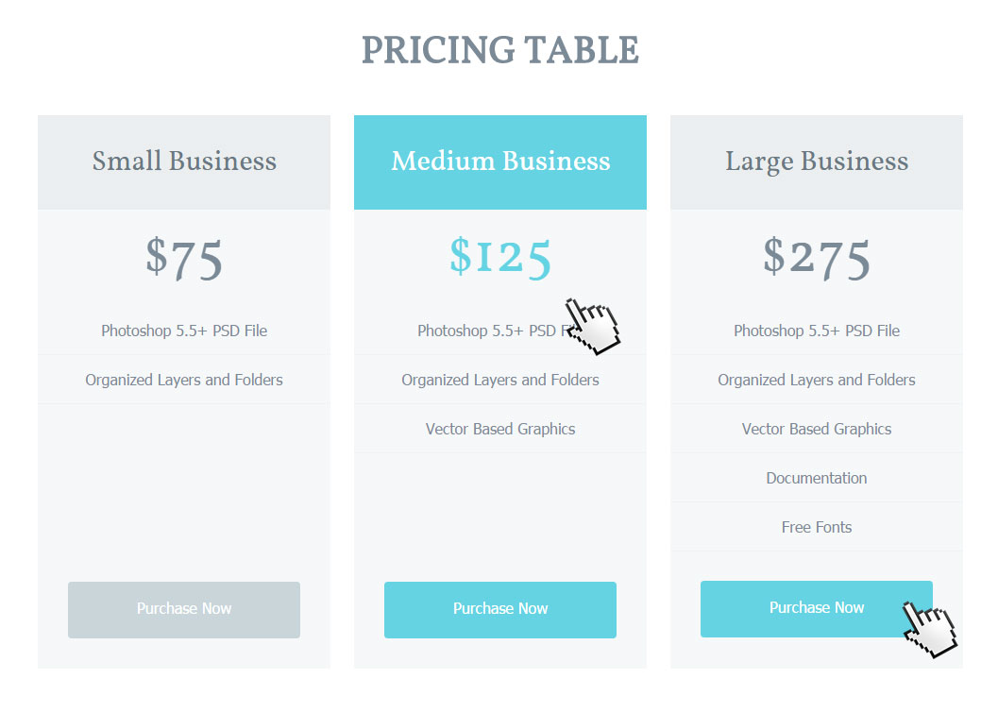

* The mouse cursors in the above screenshots explain what happens when the mouse moves over a project or a group and when the browser window resizes.

### Input

You are given the above screenshots + all required images + the texts on the site.

### Output

The output should be valid HTML5 + CSS3 + images that implement the above Web page.

### Constraints

* The layout should be 1000px.
* Use google font **Vollkorn** - <https://www.google.com/fonts#UsePlace:use/Collection:Vollkorn>
* 'Vollkorn', serif; (size: 40px for the title, 30px for the subtitle, 60px for the price).
* Font: 16px Tahoma, sans-serif for the main text.
* The site should open correctly in Chrome 35.
* Pixel-perfect implementation is not required.